1. **WHAT IS COMPUTER?**

* A computer is a complex machine that is programmed to perform various tasks. This device circulates its function on manipulating the information and data stored on the system. This includes storing, retrieving, and processing the data.

1. **WHAT ARE THE ESSENTIAL PARTS OF COMPUTER?**

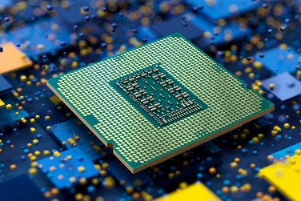Central Processing Unit - Serves as the coordinator of communication among different parts. It acts as the brain of the computer, processing instructions and managing the flow of data between all other components to ensure the system operates smoothly and efficiently.

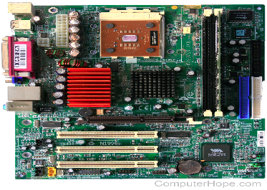Motherboard - Supplies the assistance for electrical/power needs of every parts included on the entire system. It serves as the main circuit hub, connecting and enabling communication between the CPU, memory, storage devices, and other hardware components.

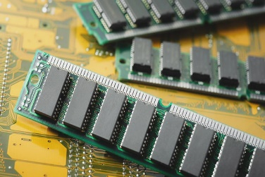 Random Access Memory - Stores, process, and commands every bits of data on the machine ensuring to make them work actively and smoothly. It ensures that the machine can quickly access and execute commands, allowing for smooth multitasking and efficient operation of applications.

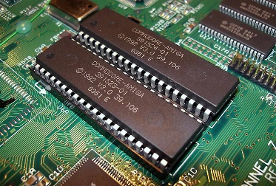Read-Only Memory - Acts as the permanent storage of the computer. It retains major instructions and data even when the power is out. It retains essential instructions and data, such as the system's firmware, even when the power is off, ensuring the computer can boot up and operate properly.

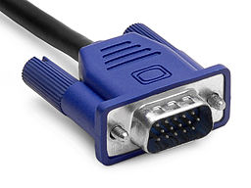Video Graphics Array Port - Is the one responsible for connecting the computer to its screen. Making the information available visually. It transmits visual information from the computer's graphics processing unit (GPU) to the monitor, making data and images available for the user to see.

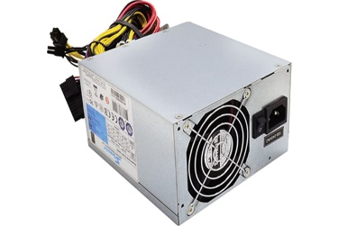Power Supply - Is the source and fuel of the entire computer unit by its ability to provide electricity. It converts the alternating current (AC) from the wall outlet into a usable form of direct current (DC) that the computer components can use.

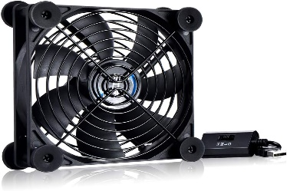Cooling Fan - Is crucial for maintaining the required temperature of a system unit. It circulates air within the system ensuring an optimal boost for the computer's functioning/performance. It circulates air to prevent overheating, ensuring that the computer operates at an optimal temperature for consistent performance and longevity.

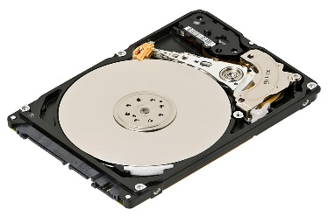Hard Drive - Is a storage device that house files, information, programs, and data. It serves as the primary repository for the system's operating system, software applications, and user data, allowing for retrieval and use when needed.

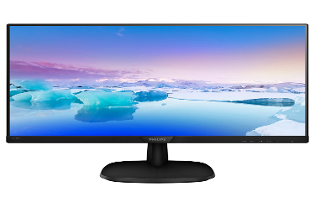Display Monitor - Is where you can view the information, programs and the whole operation of the system. It visually represents the data processed by the computer, enabling users to interact with and interpret the results of their commands.

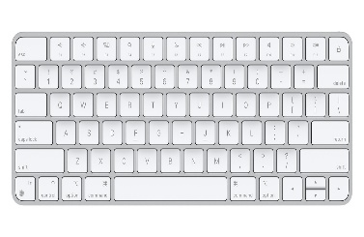 Keyboard - Is used as an input tool for text, characters, and commands. This is an essential especially with communicating with the computer. These texts and commands are responsible for every function that is instilled on a computer unit.

**3.WHO ARE THE NOTABLE INVENTORS OF HARDWARE AND SOFTWARE?**

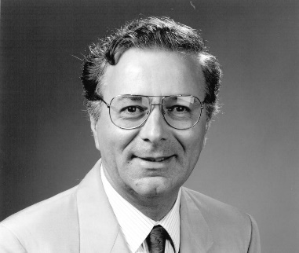Hardware developers:

Federico Faggin(Inventor of the first CPU) - The "Intel 4004" was created by said Italian Physicist in 1971.

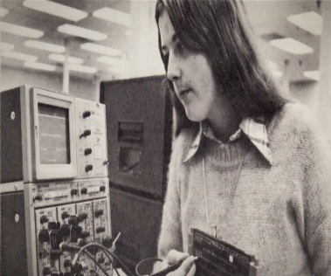Patty McHugh(Inventor of the first Motherboard) - The "Planar Breadboard" was created by the said IBM engineer in 1981.

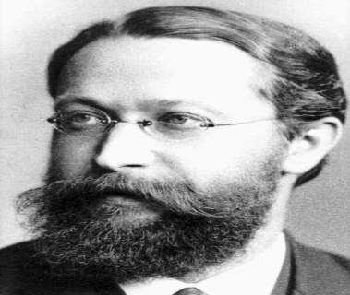Karl Ferdinand Braun(Inventor of the first Monitor) - The "cathode-ray tube (CRT)" was created by the said "Father of the Monitor" in 1897.

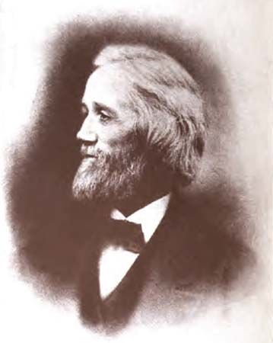Christopher Latham Sholes(Inventor of the first Keyboard) - The "QWERTY keyboard" was created by the said American inventor in 1874.

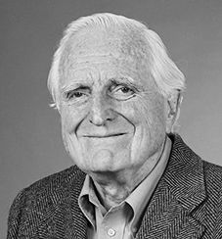Douglas Engelbart(Inventor of the first Computer Mouse) - The so called "first computer mouse" was created by the said American inventor in 1970.

Software developers:

Bill Gates(Microsoft) - The "Microsoft" was founded by Bill Gates alongside Paul Allen on April 04, 1975. Microsoft products became significant in our daily lives by its useful tools such as Word, Excel, Powerpoint and etc.

Mark Zuckerberg(Facebook) - The "Facebook" was founded Mark Zuckerberg alongside his colleagues in February 04, 2004. Facebook has been one of the key contributor of communication around the globe with its vast popularity.

Paul Buchheit(Gmail) - The "Gmail" was project started by the said developer which then is launched on April 01, 2004. Gmail has been one of the major communication tools especially in professional world.

Tim Bray(XML) - The "XML" was founded by the gorup of Tim Bray in the late 1990s. XML outlines the rules and protocols used to define, store, and share data between computer systems. These rules simplify data exchange between websites, applications, and databases on any network.

Ada Lovelace(First programming language) - The "Ada programming language" was created in 1980. The first programming language served as a model for other programming languages which then now we have tons of languages to choose from.

REFERENCES:

GCFGlobal Learning. (n.d.). Computer basics: What is a computer?. GCFGlobal.org. https://edu.gcfglobal.org/en/computerbasics/what-is-a-computer/1/

Tech, A. B. (2024, January 4). 10 Main Components of a Computer System and their Functions. A Better Tech. https://bettercomputertech.com/2024-01-04-ten-components-functions/

Powell, P. (2024, May 20). The history of the central processing unit (CPU). IBM Blog. https://www.ibm.com/blog/central-processing-unit-history/

‌Volle, A. (2023, April 21). Motherboard | Definition, History, & Facts | Britannica. Www.britannica.com. https://www.britannica.com/technology/motherboard

Father of Monitor – Know Who Invented Computer Monitor & How! (n.d.). Testbook. https://testbook.com/articles/father-of-monitor

The Editors of Encyclopedia Britannica. (2019). Christopher Latham Sholes | American inventor. In Encyclopædia Britannica. https://www.britannica.com/biography/Christopher-Latham-Sholes

History.com Editors. (2015, October 9). Microsoft founded. HISTORY; A&E Television Networks. https://www.history.com/this-day-in-history/microsoft-founded

History.com Editors. (2019, October 24). Facebook launches. HISTORY; A&E Television Networks. https://www.history.com/this-day-in-history/facebook-launches-mark-zuckerberg

Today In History: Google Launches Gmail | April | 2022 | Blog | Gottesman Libraries | Teachers College, Columbia University. (n.d.). Teachers College - Columbia University. https://library.tc.columbia.edu/blog/content/2022/april/24703---today-in-history-google-launches-gmail.php

Introducing XML, its history, what it is, its significance. (n.d.). Www.itwriting.com. https://www.itwriting.com/xmlintro.php

Kanade, V. (2023, March 8). Understanding XML, Its Elements, and Benefits | Spiceworks. Spiceworks. https://www.spiceworks.com/tech/tech-general/articles/what-is-xml/

Ada | computer language. (n.d.). Encyclopedia Britannica. https://www.britannica.com/technology/Ada-computer-language